**zkMe zkKYC Levels**

zkMe supports various levels of user verification, each of which can be further augmented by numerous add-ons. The level of verification and add-ons chosen will directly influence the data users are required to provide, and consequently, their experience with zkMe.

**Available Levels**

| Levels | Credentials | Meaning |
| --- | --- | --- |
| basic | 1. 1.   **zkPoP - Personhood** | Liveness check, uniqueness check for more details, please check: [**MeID - Anti-Sybil Suite**](https://docs.zk.me/zkme-dochub/meid-anti-sybil-suite)​ |
| standard | 1. 2.   **zkPoC - Citizenship**   1. 3.   **AML check**   1. 4.   **KYT check** | ID document verification, Liveness check, Age of Majority, PEP/Sanction lists, Adverse media |
| advance | 1. 5.   **zkPoR - Residence**   1. 6.   **Accredited Investor Checks** | ID document verification, Liveness check, Age of Majority, PEP/Sanction lists, Adverse media, accredited investors |

Here's the KYC levels specifically for zkMe:

**Basic Level:**

At the Basic level of zkMe's verification process, users are required to provide:

* **Proof-of-Personhood:** This ensures the user is a real individual.
* **Liveness check:** This verifies the user is a living person and not a bot or using a fake identity.
* **Uniqueness check:** This ensures that the user is not already registered in the system, preventing duplicate accounts.

Full homomorphic encryption is implemented here to protect users' faceprint privacy, for more details, please check [**MeID - Anti-Sybil Suite**](https://docs.zk.me/zkme-dochub/meid-anti-sybil-suite)​

**Standard Level:**

The Standard level includes all the requirements of the Basic level, plus:

* **Proof-of-Citizenship:** Verification of the user's legal status in a given country.
* **Anti-Money Laundering (AML) profile check:** These checks are designed to prevent financial crimes.
* **Transaction Monitoring (KYT) profile check:** Analysis of user's transaction behavior for any suspicious patterns.
* **ID document verification:** Requires users to provide a valid ID as proof of their identity.
* **Adulthood check:** Verification that the user is of legal age in their jurisdiction.
* **PEP (Politically Exposed Persons) / Sanction Lists:** Checks to see if the user is on any international sanction lists or is classified as a PEP.
* **Adverse Media:** Screening of global media sources to identify any negative news about the user.

Private Set Intersection and zero knowledge proofs are implemented here to protect users' demographic data privacy.

**Advanced Level:**

The Advanced level includes all the requirements of the Standard level, plus:

* **Accredited Investor Verification:** Verification that the user meets the criteria to be classified as an accredited investor, typically requiring certain income levels or net worth (on-chain).

The add-ons supplement each level of verification by requiring additional data or conducting extra checks. The specific requirements and levels of verification can differ based on the add-ons chosen and zkMe's policies, which are designed to comply with relevant laws and regulations. Users should refer to zkMe's specific KYC policy for exact details.

# zkMe App

## App Overview

The zkMe App is the front-end access to a decentralized and secure SSI wallet that uses MPC cryptography. It allows users to manage and store their identity information, either as VCs or anonymized VPs (in form of SBT). With MPC technology, private keys used for data encryption and signing are distributed across multiple nodes or devices, removing the need for a single device to store them. This significantly reduces the risk of data breaches or unauthorized access. The following sequence diagram shows the sequence of a holder creating their SSI wallet.

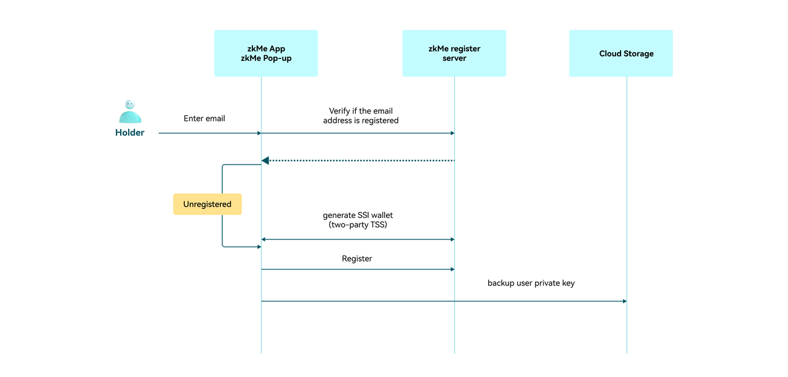

## Install

If you have not installed zkMe app yet, please download and install it:

🍎 [iOS](https://apps.apple.com/hk/app/zkme/id1672915706?l=en-GB)​

🤖 [Android](https://play.google.com/store/apps/details?id=com.zkme.app)​

## Create your first SSI wallet

To create your first SSI wallet, you have to first verify a valid email address. Simply check out the following steps:

### Step 1:

Launch the zkMe app, read the introduction to the last page and click the "**Get started**" button.

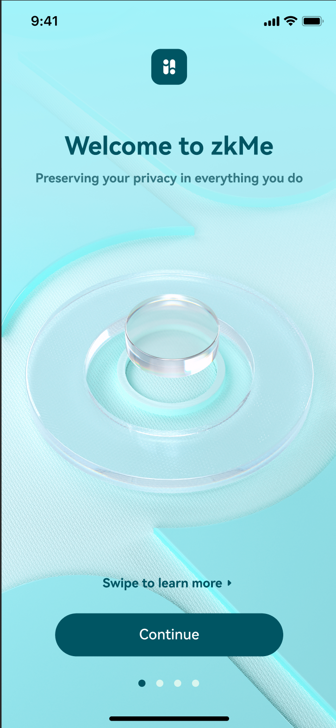

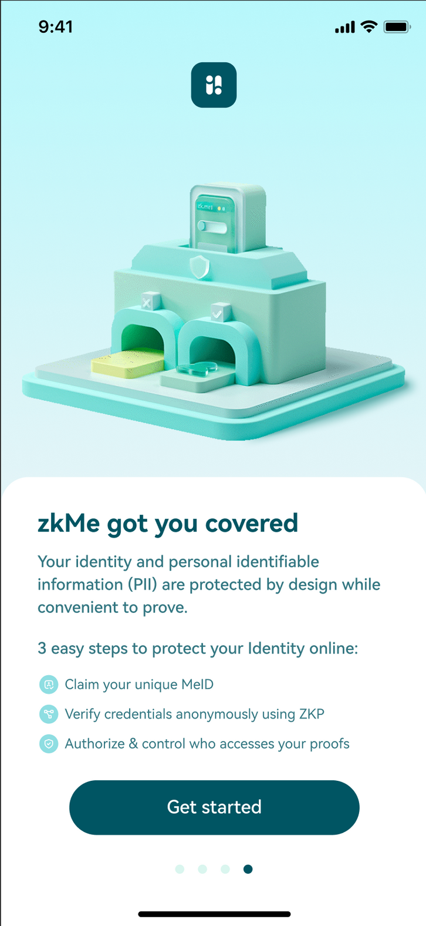

### Step 2:

Fill in your email address on this page and click the "**Continue**" button. Make sure to provide a valid email address. Or you can also register through your **Apple ID** or **Google account** at the bottom of the page.

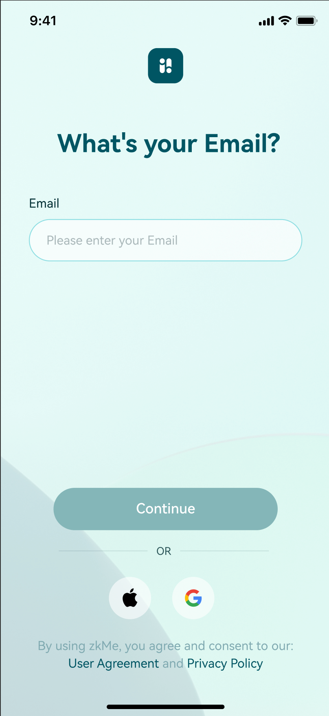

### Step 3:

Check your email box and find an email named "Sign in to zkMe". Click the verification link in it and finish the process.

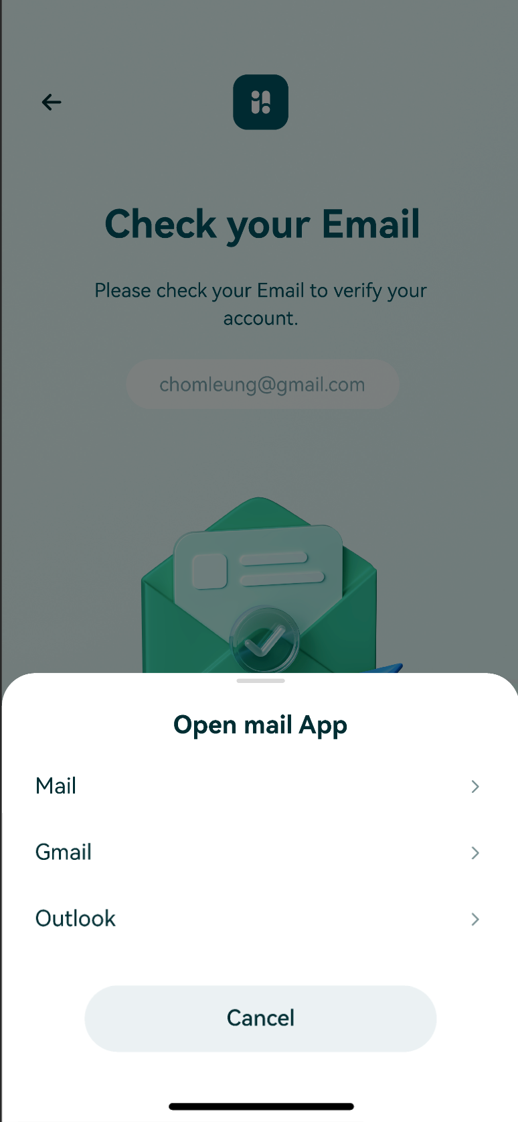

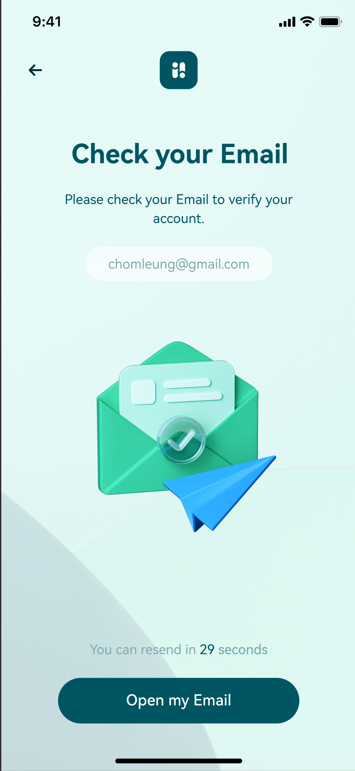

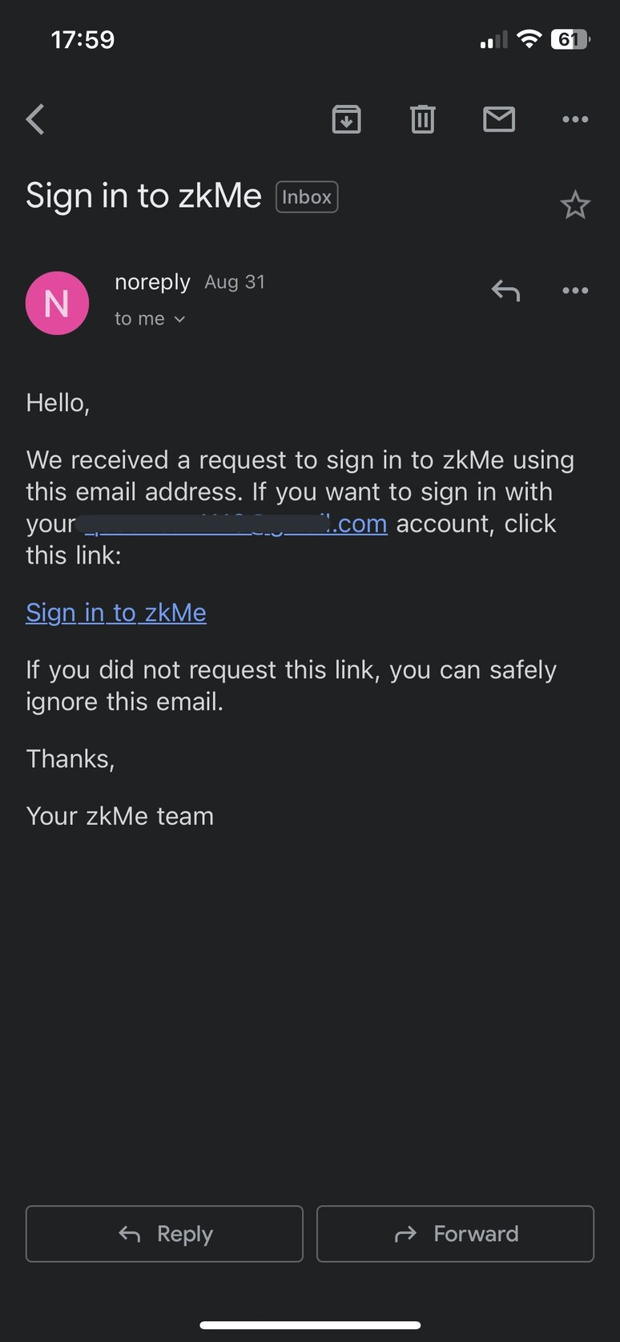

### Step 4:

After your email has been verified successfully, it will go back to the zkMe app automatically and ask you to set a zkMe domain. Fill in a valid domain that can not be used to identify you, then click the "**Continue**" button to get your first SSI wallet created.

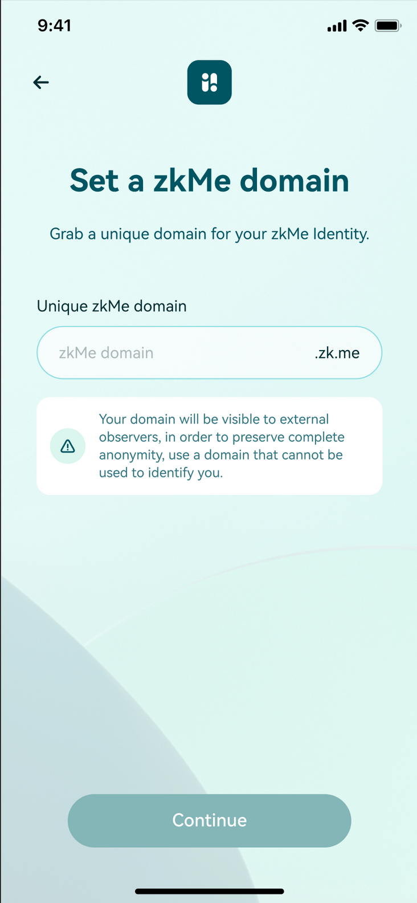

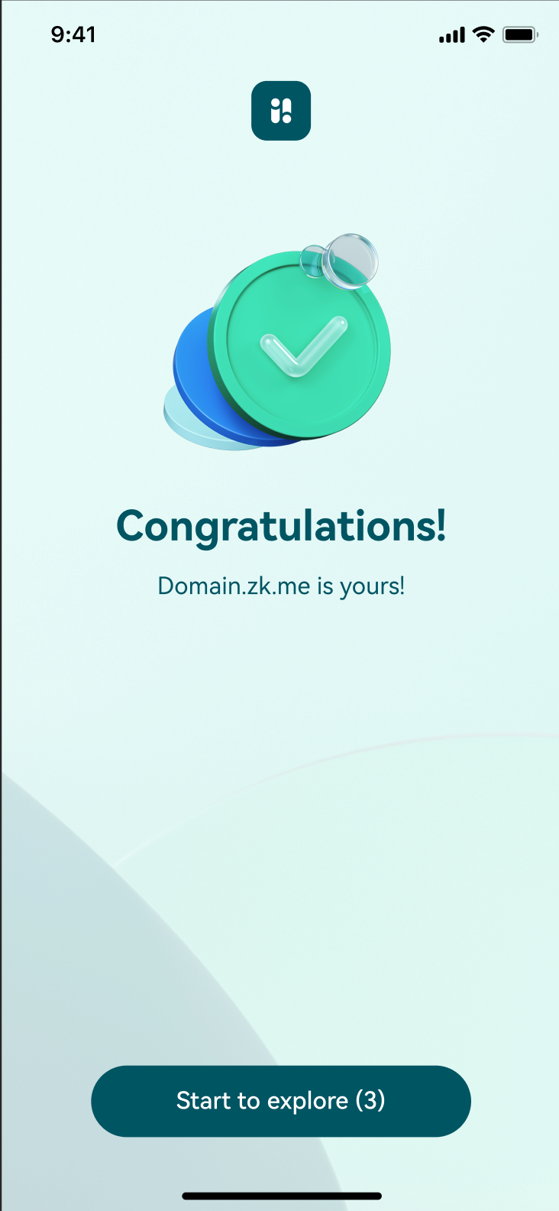

## Mint your zkMe SBT

To mint a zkMe SBT you have to pass the proof-of-citizenship (PoC) verification process. The verification process includes scanning your identity document and your face. To ensure personal privacy and security, your identification information will be encrypted, and we will not store your facial information.

After successfully signing into your account, you can simply start to mint your first zkMe SBT by clicking the "**Get it**" button on the **Identity Soulbound Token** part and follow the steps below.

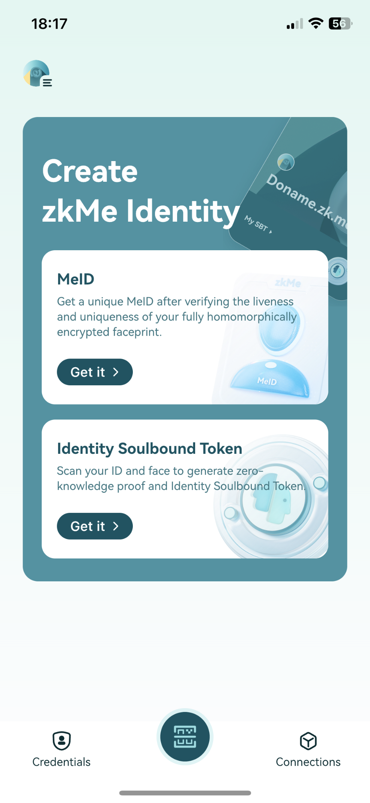

### Step 1:

Set a PIN code for your security first. Then click the "**Start Verification**" button to start the process.

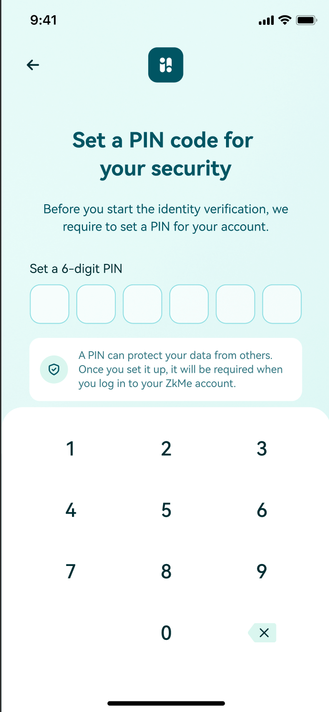

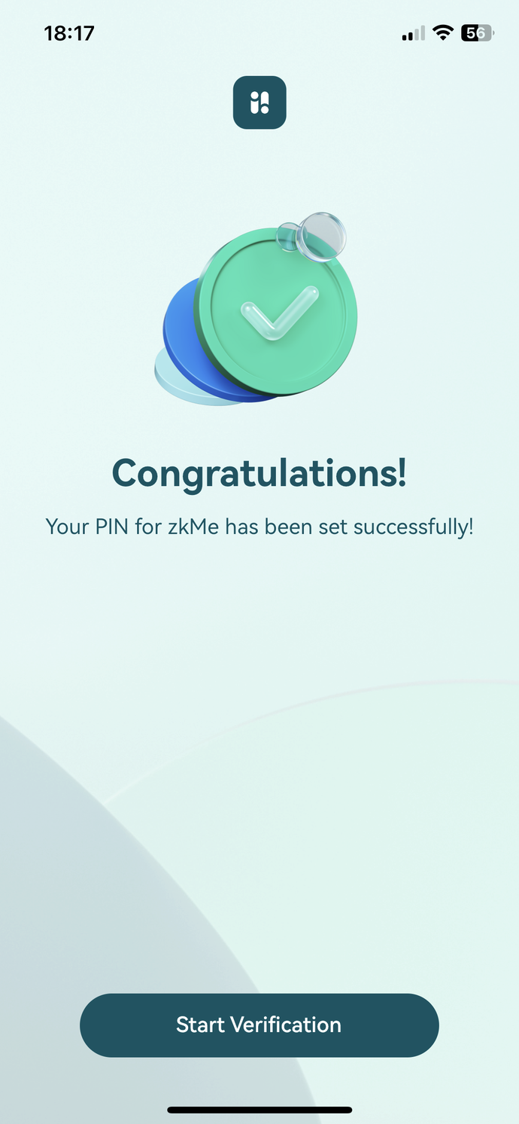

### Step 2:

Check out the verification process of proof-of-citizenship (PoC) and click the "**Verify Now**" button to continue.

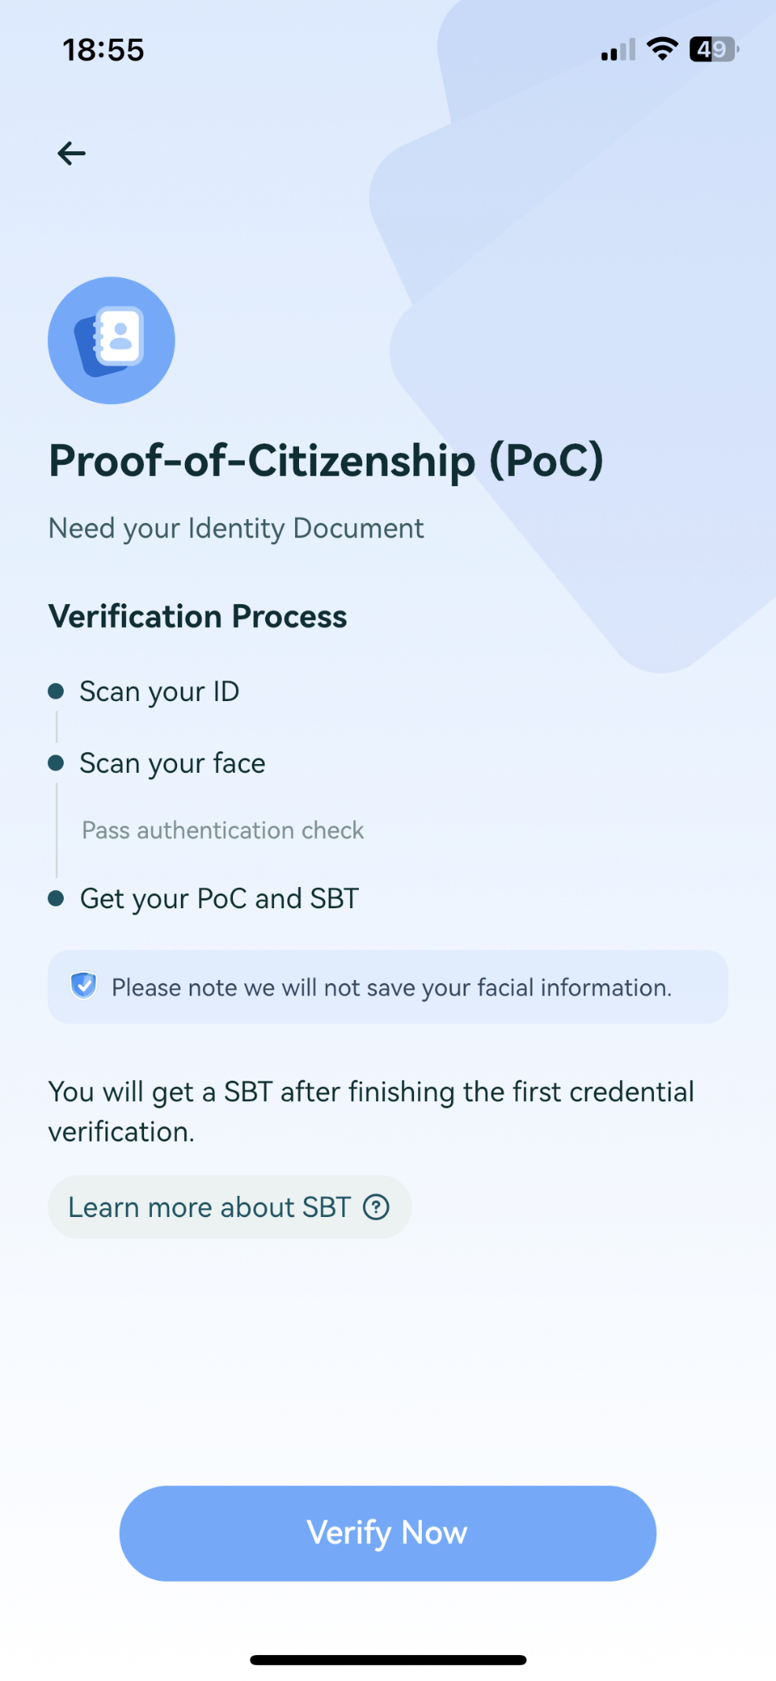

### Step 3:

Select your country on this page, and choose an identity document type to start scanning.

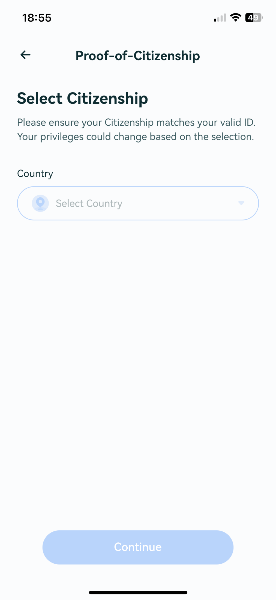

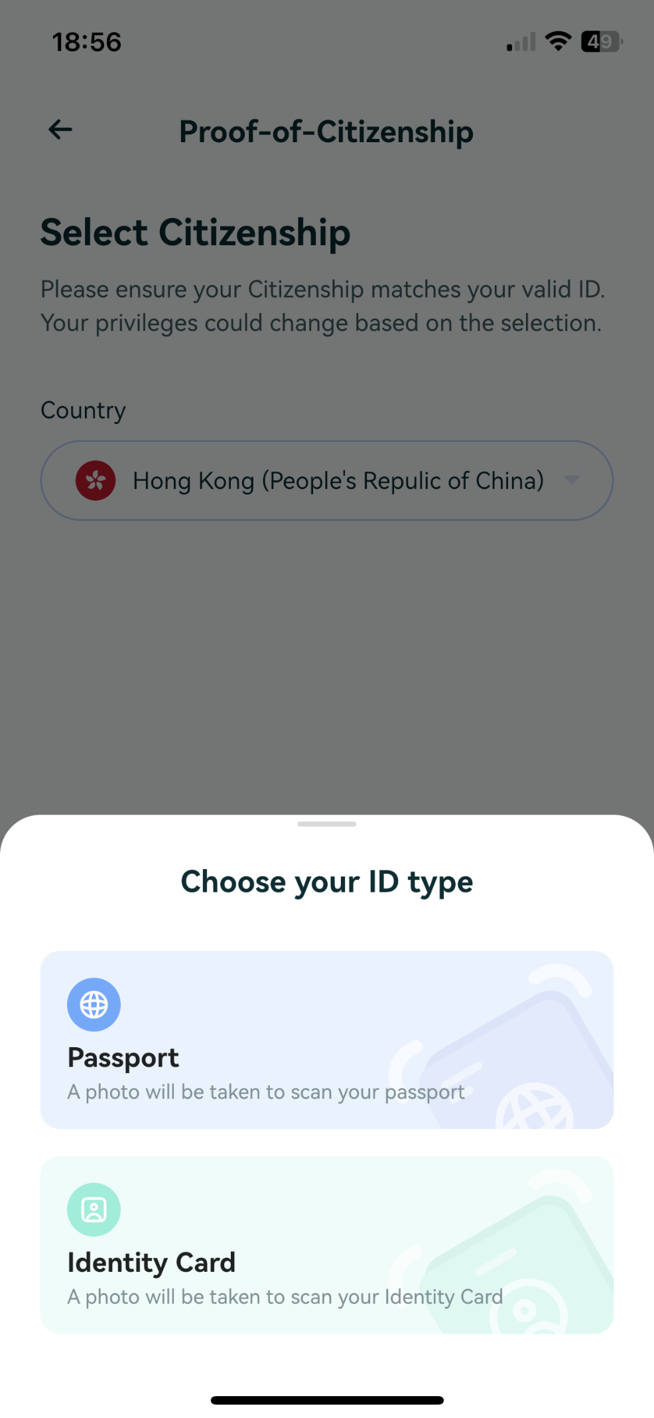

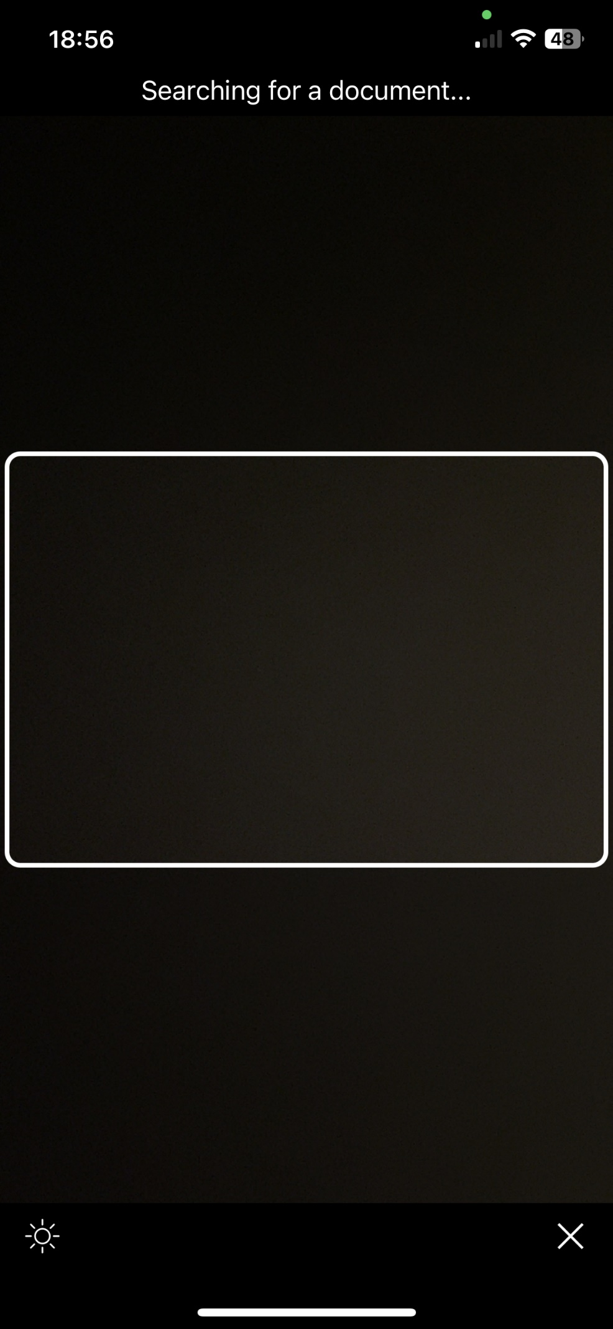

### Step 4:

After successful document scanning, confirm that the identified information is correct on this page. Then check the box at the bottom to make sure you agree with the privacy policy and user agreement and click the "**Continue**" button to proceed with facial recognition.

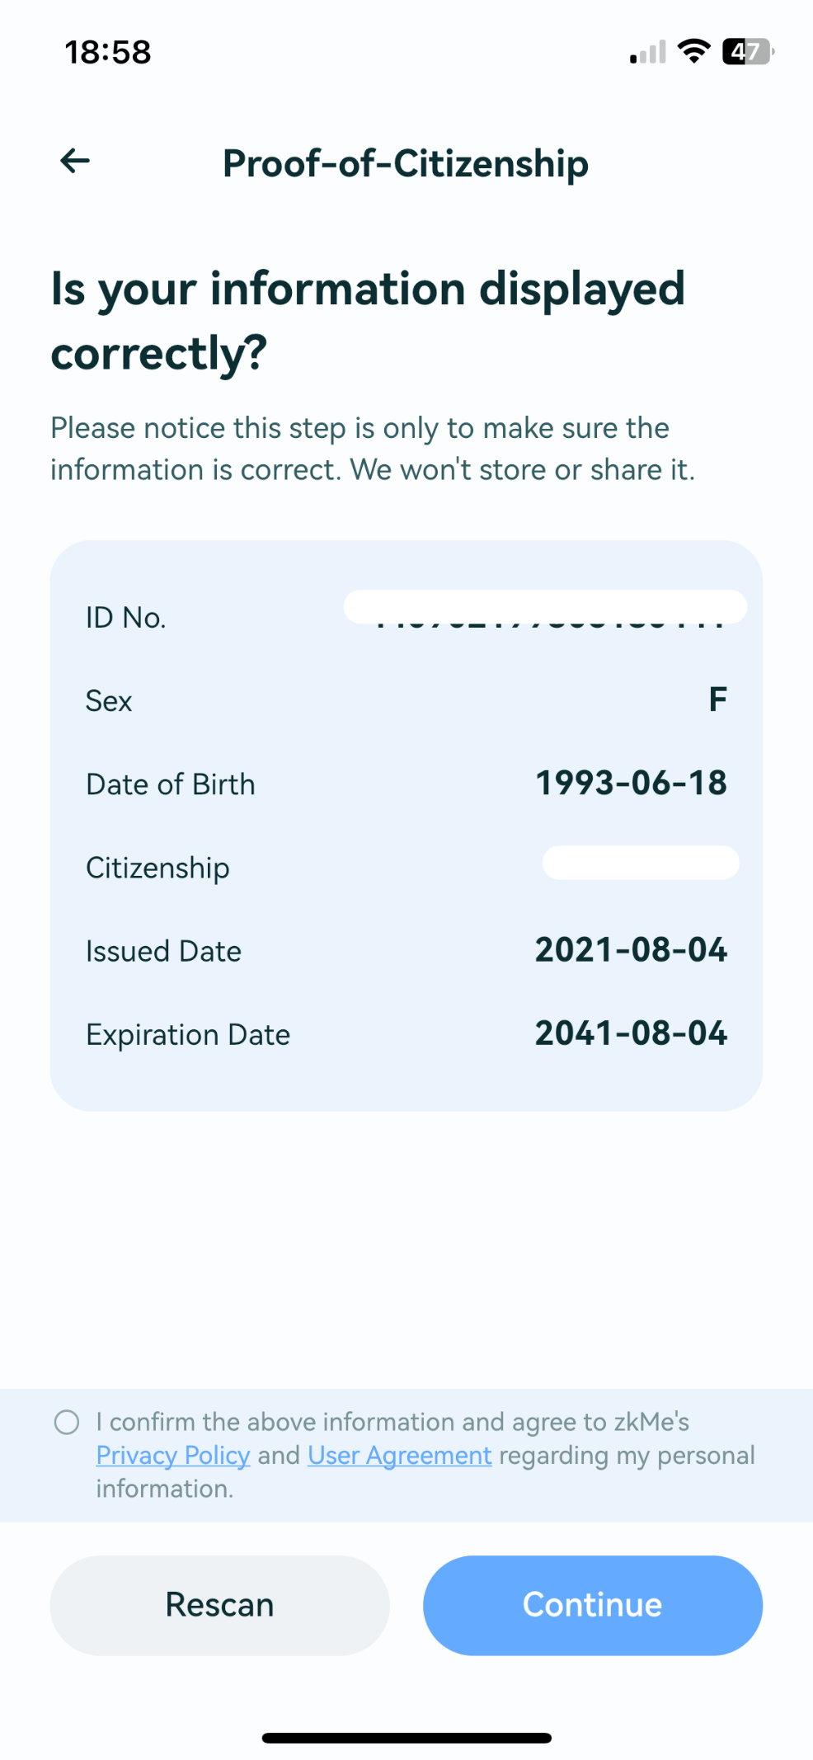

### Step 5:

On this page, click the "**Continue**" button to scan your face.

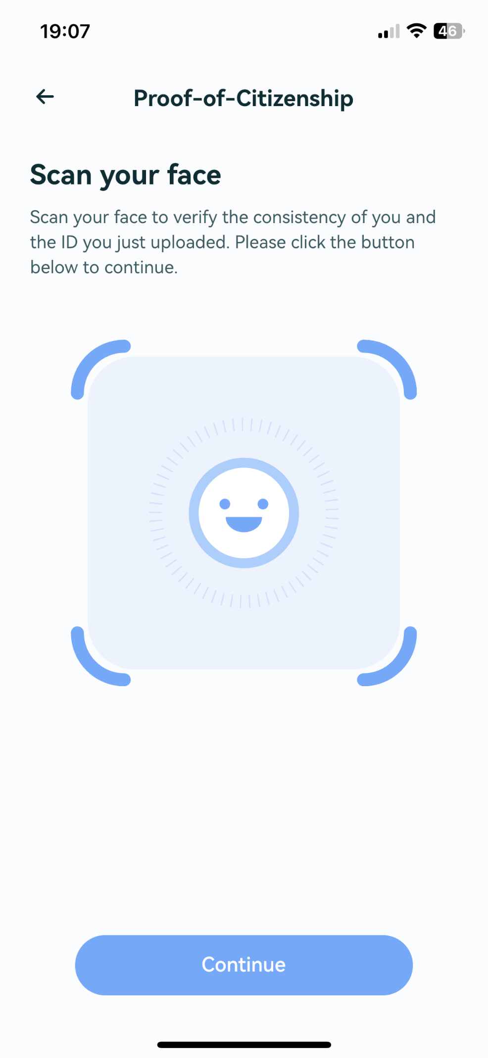

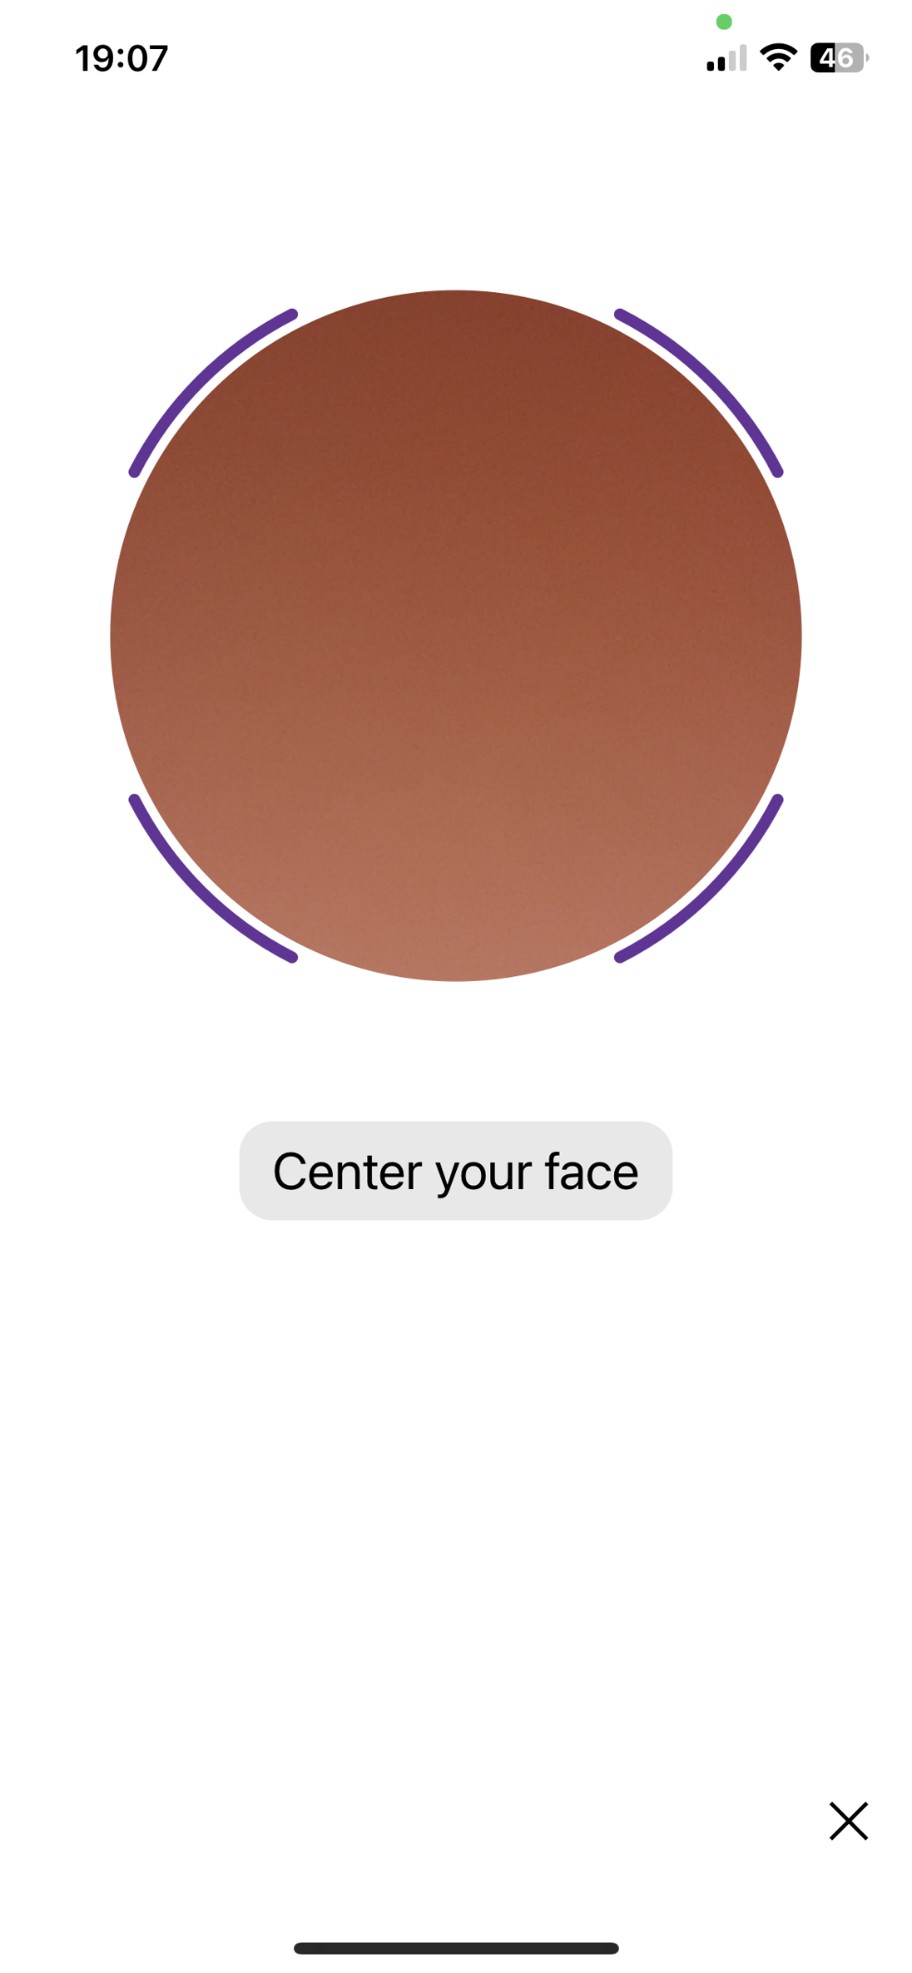

### Step 6:

After successful facial recognition, it will automatically start the ZKP generation process.

Please notice this process may take up to a few minutes and the page has to be kept. Otherwise, you will need to manually restart the ZKP generation process to complete the remaining steps.

After the ZKP is generated, it will automatically start minting your SBT. And now you can go back to the home page by clicking the "**Done**" button on the success page and check out the SBT status on the **Identity Soulbound Token** part.

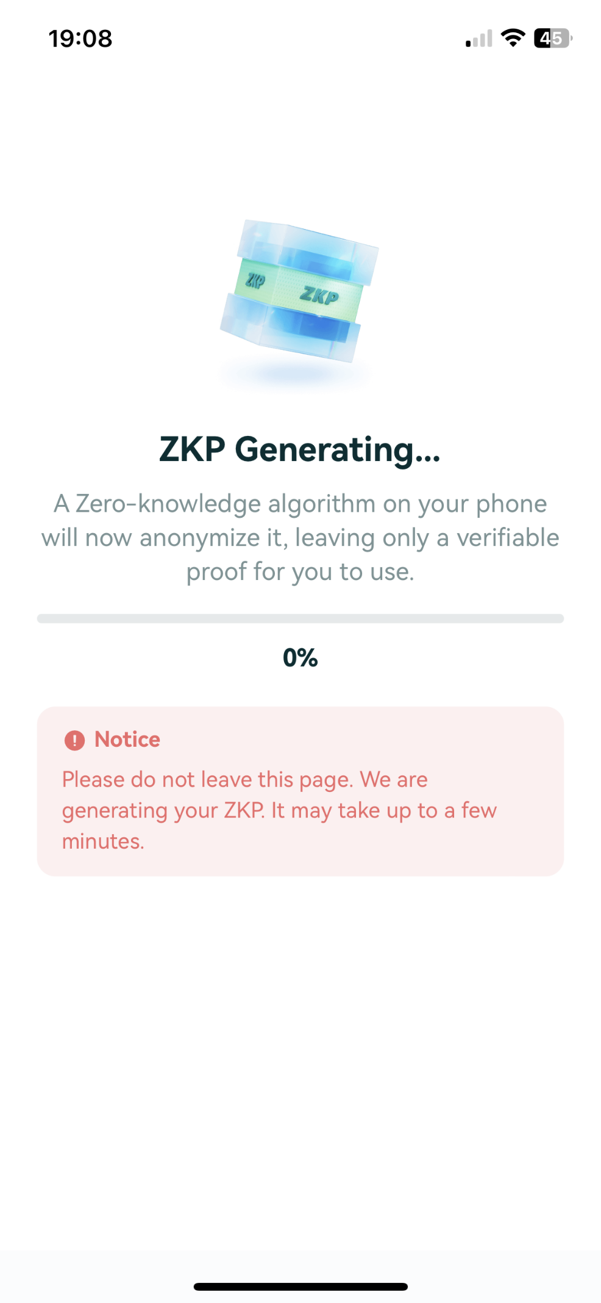

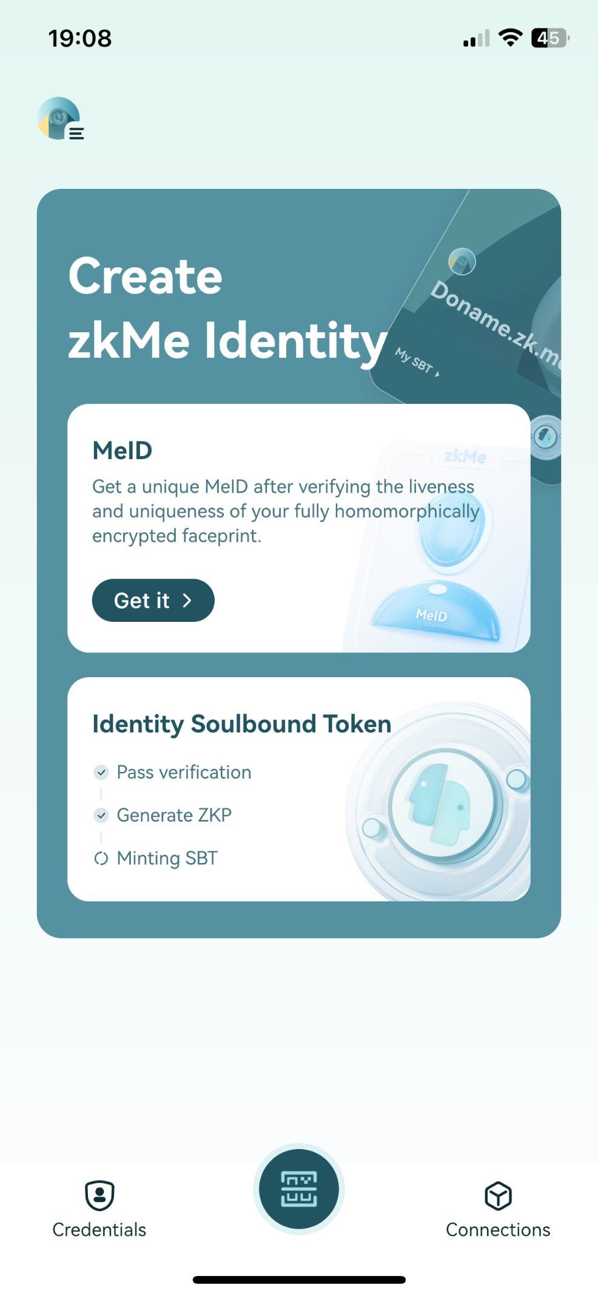

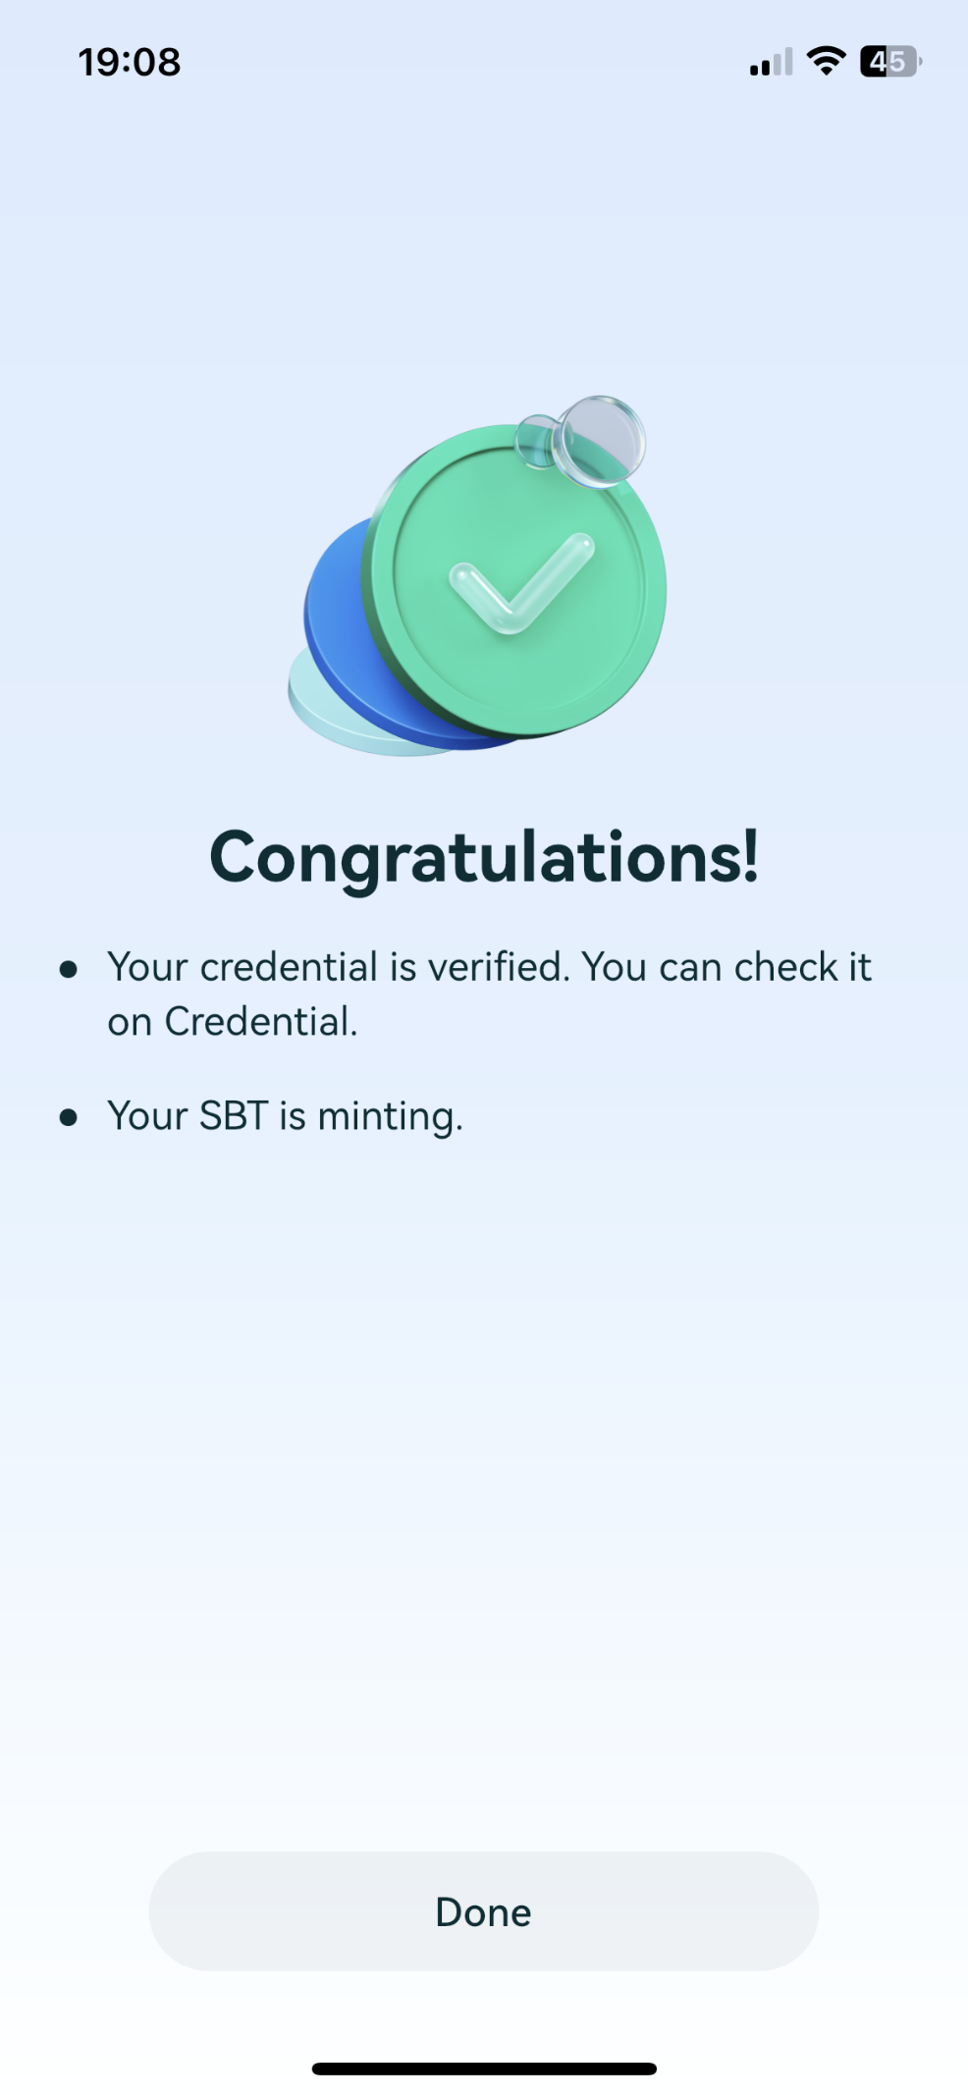

### Step 7:

Once your SBT is minted, you will see the "**Already got**" status on the **Identity Soulbound Token** part.

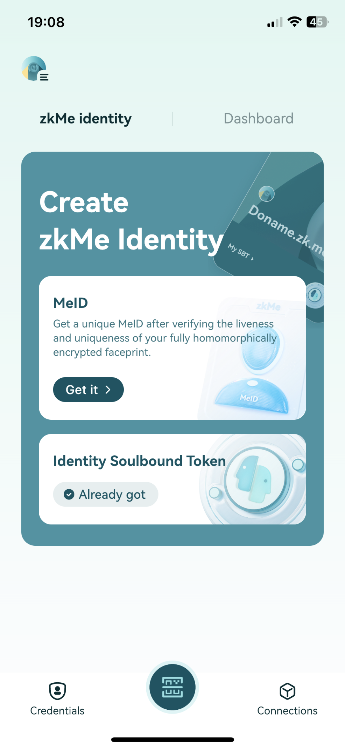

### Download zkMe App

🍎 [iOS](https://apps.apple.com/hk/app/zkme/id1672915706?l=en-GB)​

🤖 [Android](https://play.google.com/store/apps/details?id=com.zkme.app)